How to master the most profitable marketing channel on the internet
5-day crash course

Nicolas Cole
May 13, 2025

What’s the most profitable marketing channel in 2025?
Email!
Why am I so confident?
Because it has a $36 return on investment for every $1 spent. That's a whopping 3600% ROI. Which blows other marketing platforms like social media straight outta the water (only $2.80 for every $1 spent.). And if you're serious about making more money on the internet, email marketing is one of the highest leverage skills you can learn.
Which is why we invited our friend Parker Worth to spend the next 5 days showing you how he’s used email to:
- Build a $20,000/month business
- Write high-converting emails in under 10 minutes
- Build a sustainable, no-hype business — one email at a time
Funny thing is, he only figured all this out because he had no other option.
Back in 2020, Parker lost everything.
His real estate business collapsed. One tenant literally held his house hostage. He spent the next three years studying copy, building his list from scratch, and writing emails every single day (even when no one was reading them).
Then in July of 2023, he launched his first course to a list of 800 subscribers and made $18K in 5 days.
By 2024 he’d made $153,311.29—all from writing simple daily emails.
He’s learned a lot about what works (and what’s a waste of time).
So he turned all those lessons into a proven system for building, growing, and monetizing an email list from scratch. It’s the same system that helped him bounce back from losing everything and build a sustainable, profitable online business with 5,100 active subscribers and a steady monthly income.
This week, you’re getting a 5-day crash course version of that system.
Each day includes AI prompts he normally only gives to students in his full course.
Here’s what he’ll cover:
- Day 1: The psychology behind emails that get results (even when you're competing against billion-dollar companies for attention)
- Day 2: A 5-minute formula that transforms ordinary emails into persuasion powerhouses
- Day 3: The 7 subject line styles that consistently pull 40–60% open rates.
- Day 4: How to write short, sticky stories that lets you sell without selling (turning every story into an irresistible buying opportunity)
- Day 5: How to write CTAs that feel like a reward (not a “pitch”) and finally get people clicking your links.
Each day builds on the last.
And by the end, you’ll be able to write persuasive emails that grow your audience and sell your products / services without being offensive or manipulative.
Before you dive in this week, there’s one thing you’ll need:
A clear idea of who you’re writing to.
When you don’t know who’s on the other side of your email:
- It’s harder to know what to say.
- It’s harder to decide which examples to use.
- It’s harder to choose what problems to write about.
Imagine tossing a pink paper flyer off a 10-story building in Time Square, NYC.
You’ve got about a .001% chance (maybe less) of that piece of paper landing perfectly in the hands of someone who cares. But if you know you’re targeting 30-year-old guys wearing Nikes hoopin’ it up at Rucker Park in Harlem, and you walk up to the court and hand deliver a flyer that says: “Free open gym runs every Saturday. Sponsored by Nike. First 10 get a pair of Kyries.” That’s a layup (pun intended).
Bottom line:
Email is way easier when you know your target.
So let’s start there.
If you already know your ideal reader, great, you’re good to go. If not, you can revisit last week’s series on finding your Information Advantage…or just run the prompt below before tomorrow’s lesson hits your inbox.
Here’s the prompt:
Act like a email marketing coach.

I want you to ask me 5 questions to help me define my ideal reader.

Only ask me one question at a time.

Begin by asking me about my current audience

(Hint: I may not have one yet.)

Then summarize who they are, what they want, and what email topics would be most useful to them.
Save the answer. It’ll make everything that follows easier—and 10x more effective.
Tomorrow, Parker will kick things off with the real reason most emails flop (and how to fix it in one sentence).
We hope you enjoy this series on email marketing from Parker.

Never write an email without THIS

This is how you compete with billion-dollar companies

Nicolas Cole

This week’s series is written by Parker Worth—email copywriter and creator of Email 365. He helps entrepreneurs build an email list that earns $2–$5 per subscriber, every single month.

Today’s lesson is the difference between emails that sell...
And emails that make people hit unsubscribe faster than a Karen denied her coupon code.
It comes down to one word:
Emotion.
See, your reader is not some rational little calculator reading your email like: "Hmm yes, a very logical point about ROI and email automation. I shall consider this further."
Nope.
Your reader is a lizard-brain animal looking for food, threat, or dopamine.
If your email doesn’t make them feel something?
You’ve already lost.

The #1 shift that changed everything for me
I used to send emails that sounded like white papers.
And guess what?
No sales. No replies. Just dead air.
Then I started studying which emails gave me the most clicks and replies. I realized the most popular ones pointed to my readers pain points. So, I shifted my messaging with hyper focus. I told stories about people who had those problems—and the consequences of not solving them.
That’s when everything changed.
My small list of 800 people created over $18,000 in income.
And I realized was just sending emotional triggers disguised as emails.
(This is how you can stand out — even against brands with billion dollar budgets.)

So how do you decide what to write about?
Here’s your cheat code:
What is your reader struggling with?
Not in theory. Today. Right now.
Think about their emotional hot buttons. The stuff that lights up their caveman brain and makes them react.
Pick one problem and write about that.
Here are a 5 emotional pains to get you thinking:
- Violations of values (They were lied to. Scammed. Ghosted.)
- Disrespect (They were ignored, overlooked, underestimated)
- Unfairness (They did the right thing… and still lost)
- Loss of control (Chaos. Overwhelm. Tech headaches.)
- Time wasted (Spinning wheels. Getting nowhere fast.)
But use these like salt.
Salt makes the steak better.
Too much? You ruin the whole meal.

Here’s your Pain Finder prompt:
Drop this into ChatGPT or Claude:
Act like an emotional copywriting strategist.

My audience is [INSERT YOUR AUDIENCE].

Give me a list of 10 painful problems they’re facing right now, written in their own voice.

Then, for each one, give me 3 ways to agitate the problem and 1 emotional consequence they’re secretly afraid of.
Use this as your source material for every email you write.

One last thing
Your job isn’t to be inspirational.
It’s to be useful.
And the most useful thing you can do? Help someone finally name the thing they’ve been feeling—but couldn’t articulate.
Once you do that?
They’ll trust you to help them solve it.
Catch ya tomorrow,
Parker

P.S. If you want to find your target audience’s unfiltered pain points—there’s a better way.
I put together a 4-step Reddit research method that shows you how to scrape comment threads, feed them into ChatGPT, and extract your audience’s biggest frustrations.
It’s like stealing a crystal ball from the internet’s most brutally honest forum.
👉 Click here for the Reddit research method.
4-Step Framework To Conduct Pain Point Research On Reddit (With AI)
If you want to “sell” anything—products, services, ideas—you need to know what people want.
More specifically: what problems they want solved in their life.
There are a bunch of ways you can do this.
- You can guess.
- You can run a survey.
- Or you can ask ChatGPT to "come up with problems."
While these “work”…
The best thing you can do is talk to a real human.
But most people don’t have the time.
So the next best option is to listen in on your target audience where they already hang out. And there is no better place than on Reddit—”the internet’s water cooler.” There are over 57 million active users and 100 million subreddits where they hang out. That’s a lot of conversations for you to eavesdrop on for every topic imaginable.
The beautiful part?
You’re hearing real people, in their own words, talk about what’s bothering them.
You can use this for:
- Writing better hooks and emails
- Validating product ideas
- Building high-converting landing pages
- And anywhere else you need to speak to pain
Here’s how it works:
Here’s how it works:
Step 1: Choose Your Keywords
Start with a specific topic and brainstorm 5–10 search terms your target audience might use when venting or asking for help.
Keep the language casual, like they’d say it—not how you’d write it.
Example for freelance writers:
- "freelance writing problems"
- "copywriting dead?"
- "can't land writing clients"
- "tired of $0.03/word gigs"
- "how do I find better writing clients?"
You can use ChatGPT to help generate a list of these based on your topic.
Here’s a prompt:
I'm researching problems for the following audience: [describe your target audience].

The topic I'm interested in is: [insert general topic, e.g. freelance writing, SaaS onboarding, losing weight, etc.]

Give me a list of 10 casual, emotionally charged phrases this audience might type into Reddit when venting or asking for help about this topic.

Use the style and tone real people use—not polished headlines.

Focus on pain, frustration, or confusion.

Format the output as a simple list of search keywords I can use to find Reddit threads.
Step 2: Find High-Engagement Reddit Threads
Ask ChatGPT (or search manually) to find 20 Reddit threads where people are discussing this topic.
Prompt GPT like this:
Find 20 Reddit threads with 30+ comments where people are discussing problems related to [insert topic].

Use these keywords: [insert list].

Return the post titles and links.
Use the Reddit Comment Scraper Chrome Extension to copy the full comment section from each thread.
Yes, it’s a manual step. But it only takes a couple seconds per thread.
Paste all scraped comments into a Google Doc or Notepad, then save as a .txt file for easy uploading into GPT later.
Step 4: Extract And Distill The Core Problems
Upload your .txt file to ChatGPT and ask it to group similar complaints, summarize them into clear problem categories, and tell you what percentage of all comments fall into each.
Prompt:
Based on this data, identify the top recurring problems people mention.

Group similar complaints together, give each group a label, and show what percentage of total comments fall into each category.
This gives you a ranked list of pain points, based on real user emotion—not guesses.

A 5-minute email framework that prints $$$
Your inbox persuasion powerhouse

Nicolas Cole
May 15, 2025

This week’s series is written by Parker Worth—email copywriter and creator of Email 365. He helps entrepreneurs build an email list that earns $2–$5 per subscriber, every single month.

Full transparency:
I try to avoid saying the same thing as everyone else…but this framework?
It works.
Because it taps into human psychology so easily.
Some big wig marketers like Neil Patel use this framework with only 100 words. And yet it drives millions in sales. You can use this framework and write freaking 6-8 sentence emails. And still get sales.
What is it?
The ol’ P.A.S. framework.
Here’s how it works:
P: Start with the problem
The first thing you want to do is brainstorm the challenges, frustrations, and pains your target audience is facing.
Problems get attention. We’re wired to notice discomfort and look for a way out. That’s why starting with the problem works.
If you’ve been following along the last 2 days…
You’ve already completed this part of the framework!
You can get caught fast by running this Pain Finder prompt with Perplexity.AI or ChatGPT deep research. You’ll get the top 10 biggest problems your market is facing in minutes (if not seconds).
📍 Grab my full "Mad-Scientist" library of ChatGPT research prompts at the end of this email. These are the 15 prompts I use to keep a fresh list of painful problems and situations I can talk about in my daily emails.
Once you have your list of problems, read through them and see which one gives you inspiration.
You want to focus on the problems you’ve solved and you have the solution to. And if you’re feeling the evil writer’s block giving you mental paralysis? Write stories about people or businesses that solved the problem.
Which (pro tip here) you can simply reply to your AI chat:
“These are great. Can you provide stories about businesses or people solving these problems with a specific solution?
For context, I am a (job, person, business owner i.e. marketer) who is (performing action i.e writing an email about dogs)”
You’ll get a buttload of examples.
Congrats. Now you have a valuable idea because it’s around a relatable problem. And now you have examples of people that solved the problem. Be the bridge that connects the solution to your audience. They’ll love you for it.
But you’re not done yet.
A: Agitate the problem
Agitation is one of the most powerful forms of copywriting you can learn.
Get it right and you’ll hit the emotional hot buttons in your reader. Making them fork out their credit cards in desperate need of a solution.
But be careful…
If you get this wrong you’ll seem salesy, and even kinda like a jerk. I’ve seen many rookie email marketer’s spam fear based emails with agitation copied all over the place. In the short term? Yes they made sales. Now? They can’t get one sale from their list.
This next lesson is super important:
Write down the negative consequences of the problem.
Say you’re in the health niche. And you see that people have a problem with brain fog. They can’t focus at work…
What are the negatives of this? Flesh em’ out:
- Lack of productivity
- Losing money
- Getting fired
- Crashing your car on the way to work
Yadda yadda yadda….
See how that works? Share personal stories of people who still struggle with brain fog. Highlight their challenges and experiences. This makes the issue more relatable and real. The worse the consequences the better. Humans are stubborn and react to extremes. So you get extra credit for finding the extreme consequences and putting it into your copy.
Here’s an example I used for my client.
He’s in the fitness niche and sells fitness coaching to executives, CEOs, and business owners.
I used a story about Oscar Munoz who is the CEO of United Airlines. Oscar was a vegan triathlete who was in excellent shape for a 57 year old right?
Wrong.
Because just a couple months into starting as the CEO, he had a heart attack. And woke up to the news that he needed a heart transplant.
Do you see how powerful that is? I’m not lying, that's a real story about a real person that the target audience can relate to. This agitation made a lot of sales and got a lotta engagement.
Creating a sense of urgency is one of the best sales tricks out there. But you need to strike a balance between urgency and being dramatic or manipulative.
The solution?
Be honest and find stories or examples that actually happened.
Let’s keep going.
S: Provide a solution
The solution is where you offer the emotional payoff.
By using the past 2 steps you’ve caught attention and showed what’s at stake if your reader doesn’t take action.
Now you’ve gotta show them the way.
All you have to do in the solution is show you provide the pain killer. The medicine that removes the pain.
The best way is to show the benefits of your product or service. Highlight the positive results people can achieve by taking action. Make it easy for them.
And there you have it.
Problem. Agitate. Solve.
Let’s look at an example so you can see all 3 pieces working together.
Problem: Are you tired of spending hours each week on little tasks that should be automated?
Agitate: That time adds up. Consider the chances you're losing due to the stress of managing many small tasks at once.
Solution: With my new software you can automate those tasks. Freeing you time and energy to focus on what really matters.
See how simple this is?
It’s only 5 sentences.
And all it takes is 5-minutes to write.
Want help?
Here’s a prompt that turns ChatGPT into your PAS email writing partner:
You are an experienced direct response email marketing specialist. You've written thousands of high-converting emails and understand the psychology behind opens, clicks, and conversions.

But for this task, you're not here to write for me.

You're here to help me write with you.

I want to write a ready-to-send email using the PAS (Problem, Agitate, Solution) framework.

We’re doing this one step at a time.

At every step: Don’t write the full email for me (unless I ask).

Guide me with questions, examples, and suggestions so I can shape the message. Act like a writing partner—not an over-eager copy machine.

Ask me one question at a time.

Wait for my response before moving on.

# Here Are The Steps

Step 1: Outline:
- Answer guided questions to help me build the outline (collaborative)

Step 2: Expand Once the outline is ready, help me expand it step-by-step.

For each section:
- Ask follow-up questions
- Offer phrasing suggestions
- Wait for my input before writing anything full-length

Keep the tone plainspoken, punchy, and clear.

Got it?

If so, let's begin.

Start by asking me what I want to write about.
Send at least one of these emails every week and you’ll become a persuasion powerhouse in no time.
That’s all for today.
Catch ya tomorrow for Day 3 of the Email 365 series,
Parker

P.S. Want the “Mad-Scientist” research intelligence library?

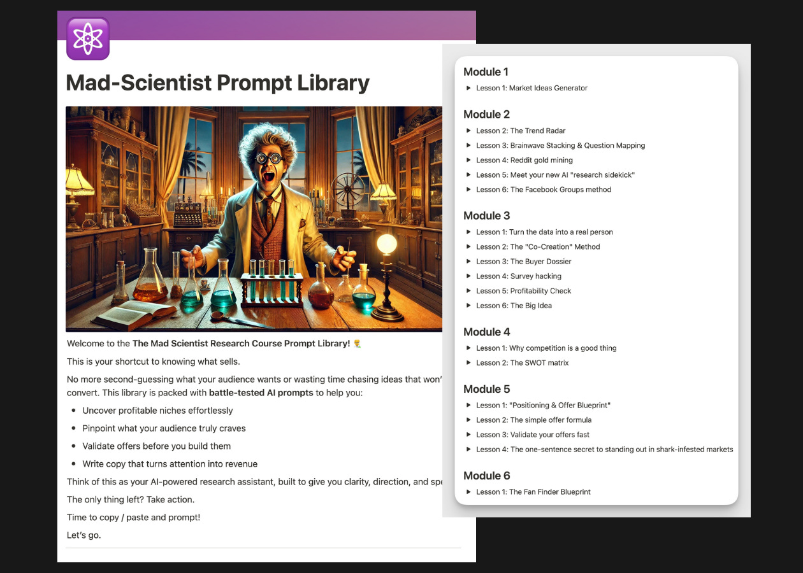

I’m a nerd when it comes to doing research for my emails, so I put together a library of my best prompts specifically for Write With AI premium subscribers.
You can grab all 15 prompts here for FREE:
>>>Click here to get your market research prompts.

7 email subject line styles that consistently deliver higher open rates

Write 100's of mouth-watering hooks in 5-minutes

Nicolas Cole
May 16, 2025

This week’s series is written by Parker Worth—email copywriter and creator of Email 365. He helps entrepreneurs build an email list that earns $2–$5 per subscriber, every single month.

Harsh truth:
You could spend two hours writing the most useful, emotional, persuasive email ever…
But if your subject line doesn’t get the open?
Nobody will ever read it.
It’s like handing someone a winning lottery ticket — then dropping it down a storm drain.
Subject lines are 80% of the game.
So let’s stack the odds in your favor.

Your Subject Line = Your Hook
It’s not a headline.
It’s not a slogan.
It’s the hook that stops someone mid-scroll in their inbox.
Your goal is to make someone pause and say: “Wait… what’s this about?” And when done right, your subject line turns your email from background noise into the main event.
A killer subject line does two things:
- It hints at a benefit. For example, “*How to get your first 10 sales (without a big list)” Clear benefit and it removes a mental obstacle.
- It creates curiosity. “THIS almost killed my launch” What’s “this”? What happened? Instant curiosity.
If you’ve got one or both?
You’re golden.

The 7 Email Subject Line Styles That Consistently Deliver Higher Open Rates
You don’t need 1,000 templates.
You only need these 7:
- Curiosity “THIS changed everything for my business.”
- Pain “Still can’t convert traffic into buyers?”
- Benefit “How to 2X your leads in 30 days”
- Story “I accidentally ordered d*ck cheese” (yes, deliverability took a hit. but replies went crazy.)
- Question “Do you make these content mistakes?”
- Contrarian “Why storytelling WON’T grow your brand (and what will)”
- Proof “How I grew to 70,000 followers in one year”
Use these to match your email type.
- Sending a story? Use a story subject.
- Giving advice? Use benefit or question.
- Writing to sell? Use pain or proof.
Mix them up. Shuffle them often.
They never go stale.

Here’s what NOT to do:
- Don’t write “Newsletter #3” (instant death)
- Don’t ask boring yes/no questions
- Don’t try to be too clever (you are not Hemingway or ChatGPT.)
Your reader isn’t grading you.
They’re skimming for something interesting.
So, give them something that stops the scroll.
How To Instantly Write 100’s Of Mouth-Watering Subject Lines With ChatGPT Or Claude

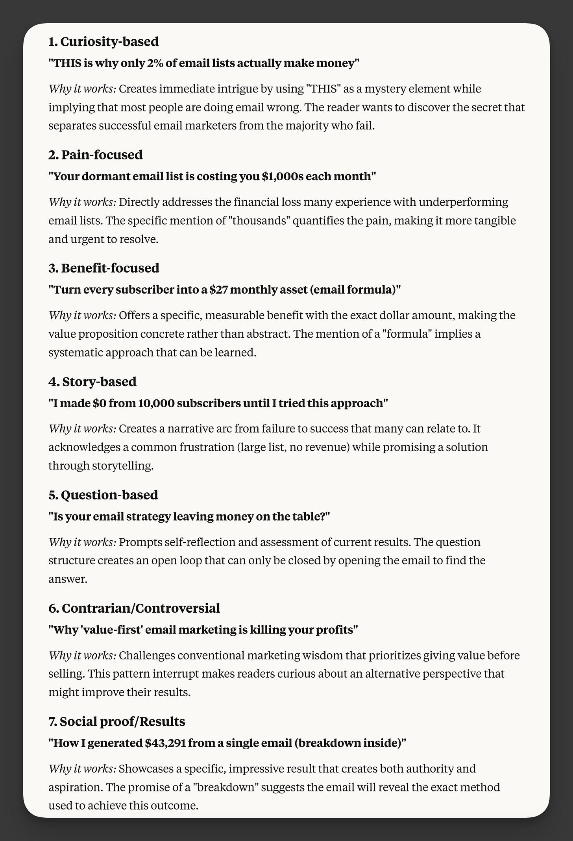

Drop this prompt into your favorite LLM:
# Context
You are an expert direct-response email marketer who has analyzed thousands of high-performing email campaigns.

You understand that subject lines are crucial - they determine whether an email gets opened or ignored. You excel at writing subject lines that grab attention, create curiosity, and get readers to open emails.

# Role
As an email subject line expert, your job is to generate multiple irresistible subject line options based on the email content or topic provided. Each subject line should be written to maximize open rates by using proven psychological triggers.

# Task
Generate 8-10 diverse, high-converting subject line options based on the email content, topic, or draft the user provides. Each subject line should follow one of these proven formats:

1. Curiosity-based: Create intrigue with "this" or unexpected elements
2. Benefit-focused: Show clear value without giving everything away
3. Story-based: Hint at an interesting narrative
4. Urgency-based: Create time sensitivity (use sparingly)
5. Question-based: Ask something relevant that prompts thought
6. Contrarian/Controversial: Challenge common beliefs
7. Social proof/Results: Showcase outcomes and success
8. Humor: Use wit to stand out (when appropriate)
9. Pain-focused: Highlight a problem your audience faces
10. Personalized: Make it feel custom-made for the reader

For each subject line, briefly explain which type it is and why it works.

# Guidelines

- Keep subject lines under 60 characters when possible
- Avoid ALL CAPS and excessive punctuation (!!!)
- Don't use "clickbait" tactics that overpromise
- Incorporate the recipient's name when appropriate using the {name} tag
- For curiosity, use the word "this" to create mystery
- For contrarian angles, challenge common advice in your industry
- For benefit-focused lines, highlight specific results
- For pain points, address specific frustrations your audience has

# Examples
Curiosity examples:

"Do THIS before bed to boost productivity"
"This changed everything for my business"
"Stop doing THIS (it's killing your conversions)"

Benefit examples:

"How to 2X your leads in 30 days"
"Get your next 1,000 followers fast"
"Lose 5 pounds this week (without starving)"

Story examples:

"I accidentally ordered **** cheese"
"Social media nearly ruined my business. Here's why:"
"240 volts showed me how to quit my job"

Urgency examples:

"Doors close in 24 hours"
"Final call: Save 50% on enrollment"
"Tonight only: get this free training"

Question examples:

"Do you make these content mistakes?"
"Struggling to lose stubborn fat?"
"Is your marketing strategy outdated?"

Contrarian examples:

"Stop following fitness influencers"
"Why hustle culture is killing your business"
"Why storytelling WON'T grow your brand (and what will)"

Social proof examples:

"Why 10,000 creators joined this program"
"How I grew to 70,000 followers in one year"
"From zero to $10k/month (proof inside)"

# Output Format

Provide 10 subject line options. 1 for each type.

Include:
- The subject line itself
- A brief explanation of why it works
- The psychological trigger it employs

Begin by analyzing the content or topic provided to understand the core message and desired outcome of the email. Then ask me any questions that what help you generate a better result (and avoid guessing). Finally ask me if I want to generate more of any 1 type.

# TOPIC

{INSERT YOUR EMAIL TOPIC/IDEA HERE}
Run it once. Then again with a different topic. Save the good ones.
Use them for future emails — or swipe the best ones for social posts too.

Pro tip:
If you're stuck? Use “THIS.”
It’s the most powerful curiosity word in subject lines.
- “THIS made me $10K last month”
- “Avoid THIS disaster at all costs”
- “I almost lost it all… then THIS saved me”
It works because it withholds the payoff — and the brain can’t stand open loops.
But don’t overdo it. “THIS fatigue” is real. Shuffle often.
That’s all for today.
Tomorrow, you’ll learn how to use simple stories (even dumb little ones) to keep your emails sticky, persuasive, and human.
Until then?
Grab your last email and rewrite the subject line using one of the 7 styles above.

Write seductive 200-word story emails in a snap

Build a cult-like following and sell while you sleep

Nicolas Cole
May 18, 2025

This week’s series is written by Parker Worth—email copywriter and creator of Email 365. He helps entrepreneurs build an email list that earns $2–$5 per subscriber, every single month.

By now, you’ve learned how to write with emotion, use a killer email framework (PAS), and write subject lines that consistently deliver higher open rates.
Today you’re gonna learn the one skill that separates forgettable marketers…
From the ones who build cult-like followings and make sales in their sleep.
That skill?
Storytelling.

Why Stories Seduce Even The Biggest Skeptics
Ever watch a movie where you already know what’s going to happen…
…but you still sit there, eyes glued to the screen?
That’s the power of narrative.
Stories bypass the logic brain and speak straight to the gut.
People buy emotionally. Stories deliver emotion. That’s why stories sell.
But here’s the problem:
Most story-based emails suck.
They’re too long, too random, or too self-indulgent. So let’s fix that.

The Simple Storytelling Formula I Use To Write Emails
I teach this as the SLO Framework:
Story → Lesson → Offer
You’re not writing novels here. You’re writing tiny scenes with a point.
Here’s the 9-point outline I use to keep things short, punchy, and effective:
- Subject Line
- Hook
- Start
- Middle
- End
- Transition
- Lesson
- CTA
- Sign-off
Write 1–2 sentences per section. That’s it.
The goal isn’t to write something clever. It’s to say something real — fast.

Stand Out In The Inbox With These 4 Kinds Of Stories
This email that landed me a mentorship with Ian Stanley:
“I accidentally ordered d*ck cheese.”
Yup.
A true story about mispronouncing pão de queijo in Brazil.
It got laughs and replies. It made me stand out.
But more importantly…
It made sales.

If you want to write stories that sell, these 4 kinds work like a charm:
Because their emotional.
- Extreme events (accidents, illness, financial disaster)
- Self-deprecating moments (embarrassment builds trust)
- Relatable struggles (missed deadlines, failed launches, creative burnout)
- Client stories (before → after with proof baked in)
Need help jogging your memory?
I’ve got you.

Here’s A Quick Method To Find Your Best Story Ideas:
Set a timer for 5-minutes.
Finish these sentences:
- I felt embarrassed because…
- I felt proud because…
- I felt jealous because…
- I felt like a total failure when…
Now pick one.
Then, tell the story in 3 parts:
- What happened?
- What changed?
- What did you learn?
Bridge to your offer using one line like:
- “Here’s what that taught me about email.”
- “Kinda like what I show you in [your product].”
- “It reminded me why this skill matters.”
Boom.
You’ve got a selling story that doesn’t feel like a sales email.

How To Write Your First SLO Email With ChatGPT Or Claude

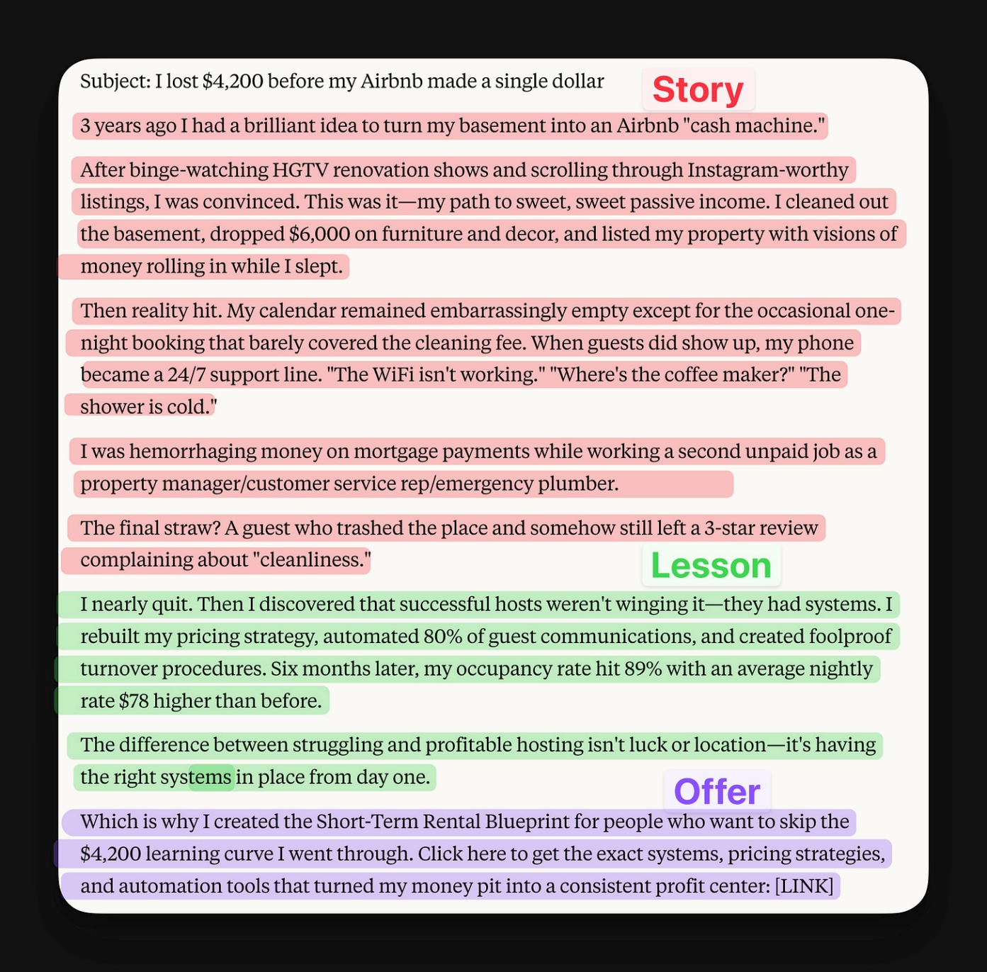

Paste this into ChatGPT or Claude and fill in the inputs:
You are a copywriter who writes high-converting sales emails that don’t feel like sales emails.

You use a storytelling framework called SLO, which stands for:

- Story
- Lesson
- Offer

Here's how:

S = Story

Tell a short, punchy story that hooks the reader.

Start – In one sentence, set the scene: who, what, when.
Use this format:
[#] [time] ago I had a [problem]

Middle – Describe the struggle and conflict. Include:
• What happened
• How it felt
• Why it mattered
• Consequences
• Attempts to solve it

End – Show the transformation.
• What was the resolution?
• What changed?

Make it vivid, emotional, and real.

~

L = Lesson

Extract a clear, valuable takeaway that ties to the reader’s situation.

No generic advice. Share what the story character learned the hard way.

This should trigger an “oh damn, that’s true” reaction.

~

O = Offer

Transition cleanly into a product or service that solves the same kind of problem.

Use bridge phrases like:

“Here’s why I bring this up…”

“If you’re dealing with something similar…”

“Which is why I made [Product Name]...”

Include a single, clear CTA.

Keep it casual—not pitchy.

Output Format:

[Story: ~150–200 words]
[Lesson: 1–2 sentences]
[Offer: 1–2 sentences with CTA link]

Tone:

• Friendly but direct
• Witty, slightly self-deprecating
• Conversational, like talking to a smart friend who writes their own emails
• No marketing fluff, no hype, no fake drama
• Speak like someone who’s been through the mess and figured it out

Writing Constraints:
• Don’t ramble in the “Start.” Get to the conflict fast.
• Don’t moralize or sound like a guru in the “Lesson.” Just share the insight like a peer.
• Don’t over-sell in the “Offer.” The CTA should feel like a natural next step.

Now here’s your input block:

Write a story-based email for [TOPIC]. The story is about someone who [STRUGGLE], and how they overcame it using [STRATEGY/FRAMEWORK/TOOL]. The goal is to show the reader what’s possible and naturally introduce [PRODUCT/OFFER] as the next step.
Rerun it a few times. Mix in your own memory. You’ll be surprised what you get.
Tomorrow we wrap this series up with a bang.
I’ll show you how to write calls to action that convert — without sounding desperate, sleazy, or like every other AI-ridden pitchfest in the inbox.
For now?
Write your 3-sentence story:
- What happened
- What changed
- What it taught you
Add a simple CTA.
You’re now doing what 99% of marketers can’t.

Why 99% of email marketers don't make a single dollar from their list

Nicolas Cole
May 19, 2025

Today’s the final lesson in our 5-day crash course on how to master the most profitable marketing channel on the internet.
And it’s probably the most important one.
Because this is where 90% of marketers fumble the bag.
You write a great hook, a killer story, and a perfectly agitated pain point...
And then you close with something like:
“Let me know if you’re interested.”
“Thanks for reading :)”
“Hope this helps.”
😵‍💫
That’s like going on a perfect date and never asking for a number.

Here’s What Most People Get Wrong About CTAs:
They make the reader think.
Big mistake.
If you want clicks, you need frictionless action.
Here’s what I mean:
❌ Don’t use words like “Register,” “Sign up,” or “Submit”
✅ Do use words like “Get,” “Grab,” “Save,” “Click,” “Watch”
Your reader doesn’t want to work.
So make the next step feel like a reward.

The Best Closing Line I’ve Ever Written
This one works for free stuff, paid offers, and low-ticket products:
“That’s just one of the tricks I show inside [Product Name]. If you want the rest, click the link below to grab it.”
Go back and look at yesterday’s email for an example.
I gave you a prompt to write an SLO email. Then at the end, I closed with: “Want more?” and dropped a link for even more email marketing prompts.
Here’s why it works:
- Recaps the value you just gave
- Hints there’s more where that came from
- Gives the reader something to click, immediately
Like I said above: the click is getting the number.
So ask for it.

Write With AI is a reader-supported publication. To receive new posts and support my work, consider becoming a free or paid subscriber.
Subscribed

A Few More Tricks To Get More Clicks
- End with urgency: “The early bird bonus expires tomorrow.”
- Add a dopamine tease: “There’s a trick in lesson 4 that made me $10K with one email.”
- Use specifics: “You’ll walk away with 3 templates you can use forever.”
And always, always include a link.
No CTA = no clicks. No clicks = no sales.

Build Your Library Of High-Converting CTAs
Paste this into ChatGPT:
You’re a world-class email marketer.

Write 10 call-to-action lines that match the tone of a helpful, smart friend — not a pushy marketer.

Each CTA should feel like a reward.

Here’s my product: [INSERT PRODUCT]

Here’s the result it helps people get: [INSERT RESULT]

Use verbs like get, grab, click, or watch.

Make the CTA feel simple, obvious, and dopamine-packed.

For example:

“Click here to grab the Email 365 course and write one high-converting email every day for a year”
Pick 3–5 and test them in the wild.
Drop them into your emails and study the results. Watch for clicks, replies, and conversions. Add the higher-performing to a swipe file that you can use over and over .

Final Thoughts
If you’ve made it through all 5 lessons, you now have the skills to:
- Find the right pain points
- Use proven frameworks
- Write punchy subject lines
- Tell stories that sell
- And close with CTAs that convert
That’s it.
99% of email marketers don't make a single dollar from their list.
Implement what you learned in this series and won’t be one of them.

